Rapid detection of metals in ash on outdoor surfaces after fires in the Wildland-Urban Interface
Isaac N. Aguilar¹, Theo Tacail¹, Merritt McDowell¹, (?)Hayward Melton¹, (?)Tristan Caro¹, (?)Haroula Baliaka¹, Mark Wronckiewicz², Ceth Parker², Julia Tejada¹, George Rossman¹, and Francois Tissot¹

Introduction
The Wildland-Urban Interface (WUI) is a discreet or gradual transition in land cover and land use from wildland vegetation to the urban built environment ¹. Fires in the WUI are fueled by a heterogeneous pre-fire mosaic varying from evergreen trees and chaparral shrub vegetation land cover types to manufactured wood and other materials in housing and electronic infrastructure in urban landscapes. While non-WUI wildfires are typically fueled only by vegetation combustion, WUI fires can also be fueled by the partial or complete combustion of structures, vehicles, and other anthropogenic fuels that can release toxic compounds like heavy metals into the environment after a fire ^{2–10}. A recent U.S. National Academies report highlights the lack of research on the environmental impact of wildfires that occur at the WUI ¹¹. Metals concentrated in the pre-fire WUI landscape can become volatilized from combustion at high temperatures, and then condense while adsorbing to ash surfaces during cooling ¹². The determining factors of the final contamination potential of wildfire ash include burn severity, fuel type and ash load, along with other factors controlling ash dispersal like post-fire climatic conditions, hydrological surface processes, and the physical characteristics of ash ¹³. Trace metal concentration in ash is highly dependent on the metal content and overall composition of the burned materials ^{5,8,14,15}. For example, the pre-1978 legacy of lead-based paint increases the risk of older structures in a pre-fire WUI to increase the total emissions and spatial distribution of those emissions after a fire ¹⁶. Few studies have focused on metal concentrations in outdoor ash from WUI fires, which often burn older structures.
The Eaton Fire, a WUI fire in Los Angeles County, was the second most destructive fire in California’s history and destroyed over 9,000 structures in the foothill communities of the San Gabriel Mountains including Altadena, Kinneloa Mesa, and Sierra Madre. The fire ignited on the evening of January 7, 2025, and exploded to more than 10,600 acres by the next day with most of the catastrophic damage occurring in the first 36 hours ¹⁷. An unusually extreme Santa Ana wind event forecasted by the National Weather Society realized sustained winds above 90 MPH and wind gusts over 110 MPH descending from the canyons¹⁸. No progress on containment was reported until January 12 as the fire perimeter expanded northward into the San Gabriel Mountains. The Eaton Fire lasted 24 days (January 7-31, 2025) and burned an area larger than 14,000 acres leading to an estimated $27.5 billion USD in damages.
The smoke plume from the Eaton Fire travelled South-West and deposited coarse, residual ashes for miles over the western coastline. Similar WUI fires have been studied to understand the post-fire environmental contamination of ash and soil with toxic concentrations of metals ^{3,4}. During the 2025 Los Angeles Fires, air quality monitors positioned miles away from the Eaton fire recorded a 110-fold increase in the hourly lead (Pb) concentrations of particulate matter particles <2.5 um (PM2.5) compared to pre-fire days ¹⁹. This collaborative effort emerged to respond to a gap in our knowledge about the composition and distribution of metals in the coarse ash fraction remaining on outdoor surfaces of the post-fire landscape.
We conducted an extensive and systematic sampling of outdoor ashes that had accumulated on impervious surfaces like street curbs both within the burn perimeter and downwind where no structures were destroyed by the fire. We hypothesized that the ash samples collected within the burned perimeter would have higher concentrations of Pb and other metals due to their proximity to combusted urban infrastructure. The friable nature of ash samples in the field motivated a swift response to avoid areas where clean-up efforts had started, and to complete sampling before any rainfall. Ultimately, we sought to use this study of the 2025 Eaton Fire to assess the outdoor environmental exposure of ashes from WUI fires, and how we can better prepare for responding to future events.
Methods
The sampling campaign was initiated on January 16th, 2025 and most samples were collected before the first post-fire rainfall on January 25th, 2025 with additional samples collected on February 3rd, 2025. Caltech and JPL teams initially sampled independently but coordinated efforts early in the campaign. A 1 × 1 mile grid overlay was developed for spatial planning, with each grid cell assigned a unique numeric ID. Using this map to guide a spatially even sampling approach, teams travelled from cell to cell collecting ash samples within the burn scar as well as along the western, southern, and eastern flanks of the Eaton fire’s edges. Within each grid cell, the specific sample sites were selected based on three criteria: (1) public accessibility, (2) presence of visible ash accumulation, and (3) minimal post-fire disturbance from cleanup activities.
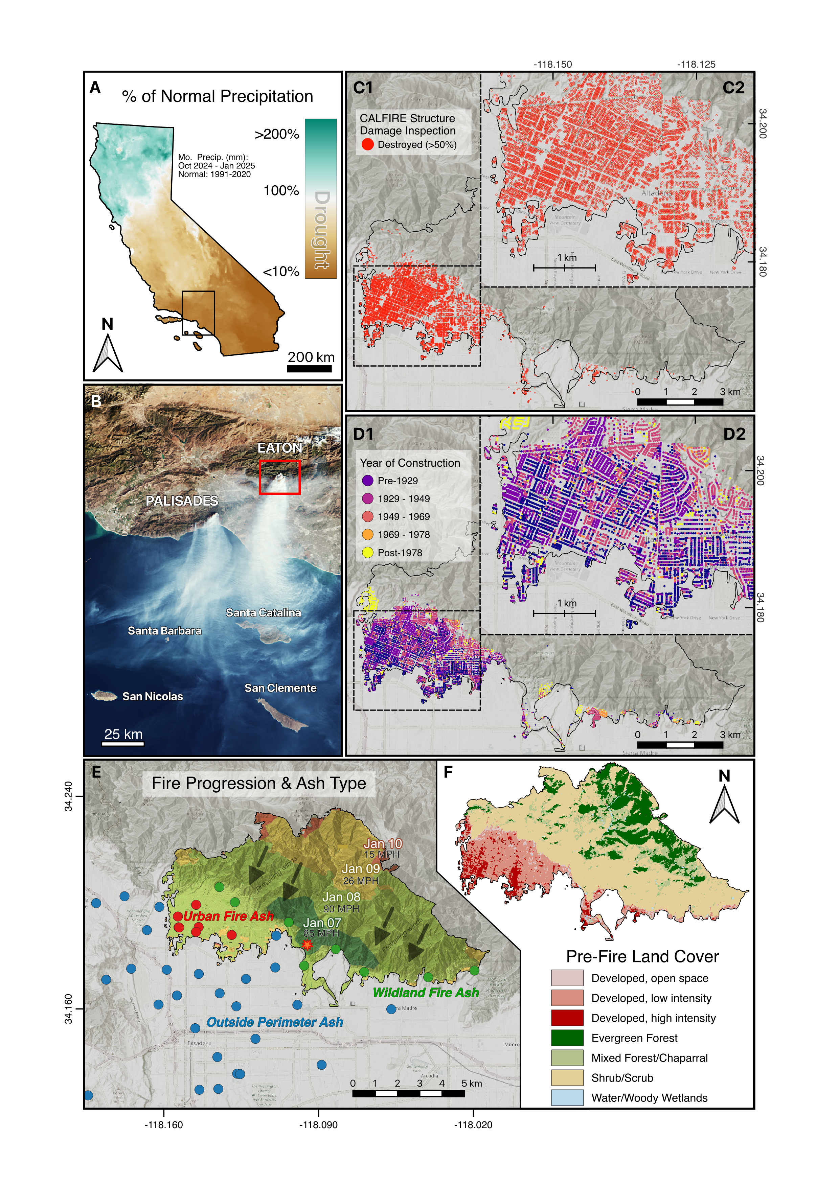
Figure 1. Map of the 2025 Eaton Fire study area with points symbolizing outdoor ash sampling locations across different pre-fire land cover types, in addition to samples collected down-wind in non-burned areas.
A total of 169 physical samples were collected directly by the sample teams (95 by JPL and 74 by Caltech), supplemented by an additional 52 samples contributed from Caltech community volunteers. As the sampling began about two weeks after the ignition, ash had largely collected in small wind-traps on impervious surfaces (e.g., on sidewalks against a fence or along street gutters). At each sample site, we identified where ash was concentrated and collected 5-15 mL of ash. The JPL team used a small nylon-bristle paint brush and plastic laboratory weight boat and Caltech teams sampled using a wooden spoon and tweezers. For each sample, the teams collect both coarser ash flakes as well as fine soot and dust to achieve a representative sample. Note that while we attempted to only collect post-fire ash material, contamination with background dust was impossible to avoid. We also avoided locations where surfaces had been swept, washed, or otherwise altered following the fire event. In some grid cell locations where ash was plentiful, 2-3 samples were taken tens to a few hundred meters apart. Each sample was immediately transferred to a sample vial and the sample identifier, location, person sampling, date, and other associated notes. Community science participants were provided with standardized collection kits including a sampling bag, spoon, and wipe for ash collection. Submitted samples were registered and visually assessed to qualify the sample quantity for appropriate experimental analysis in the lab.
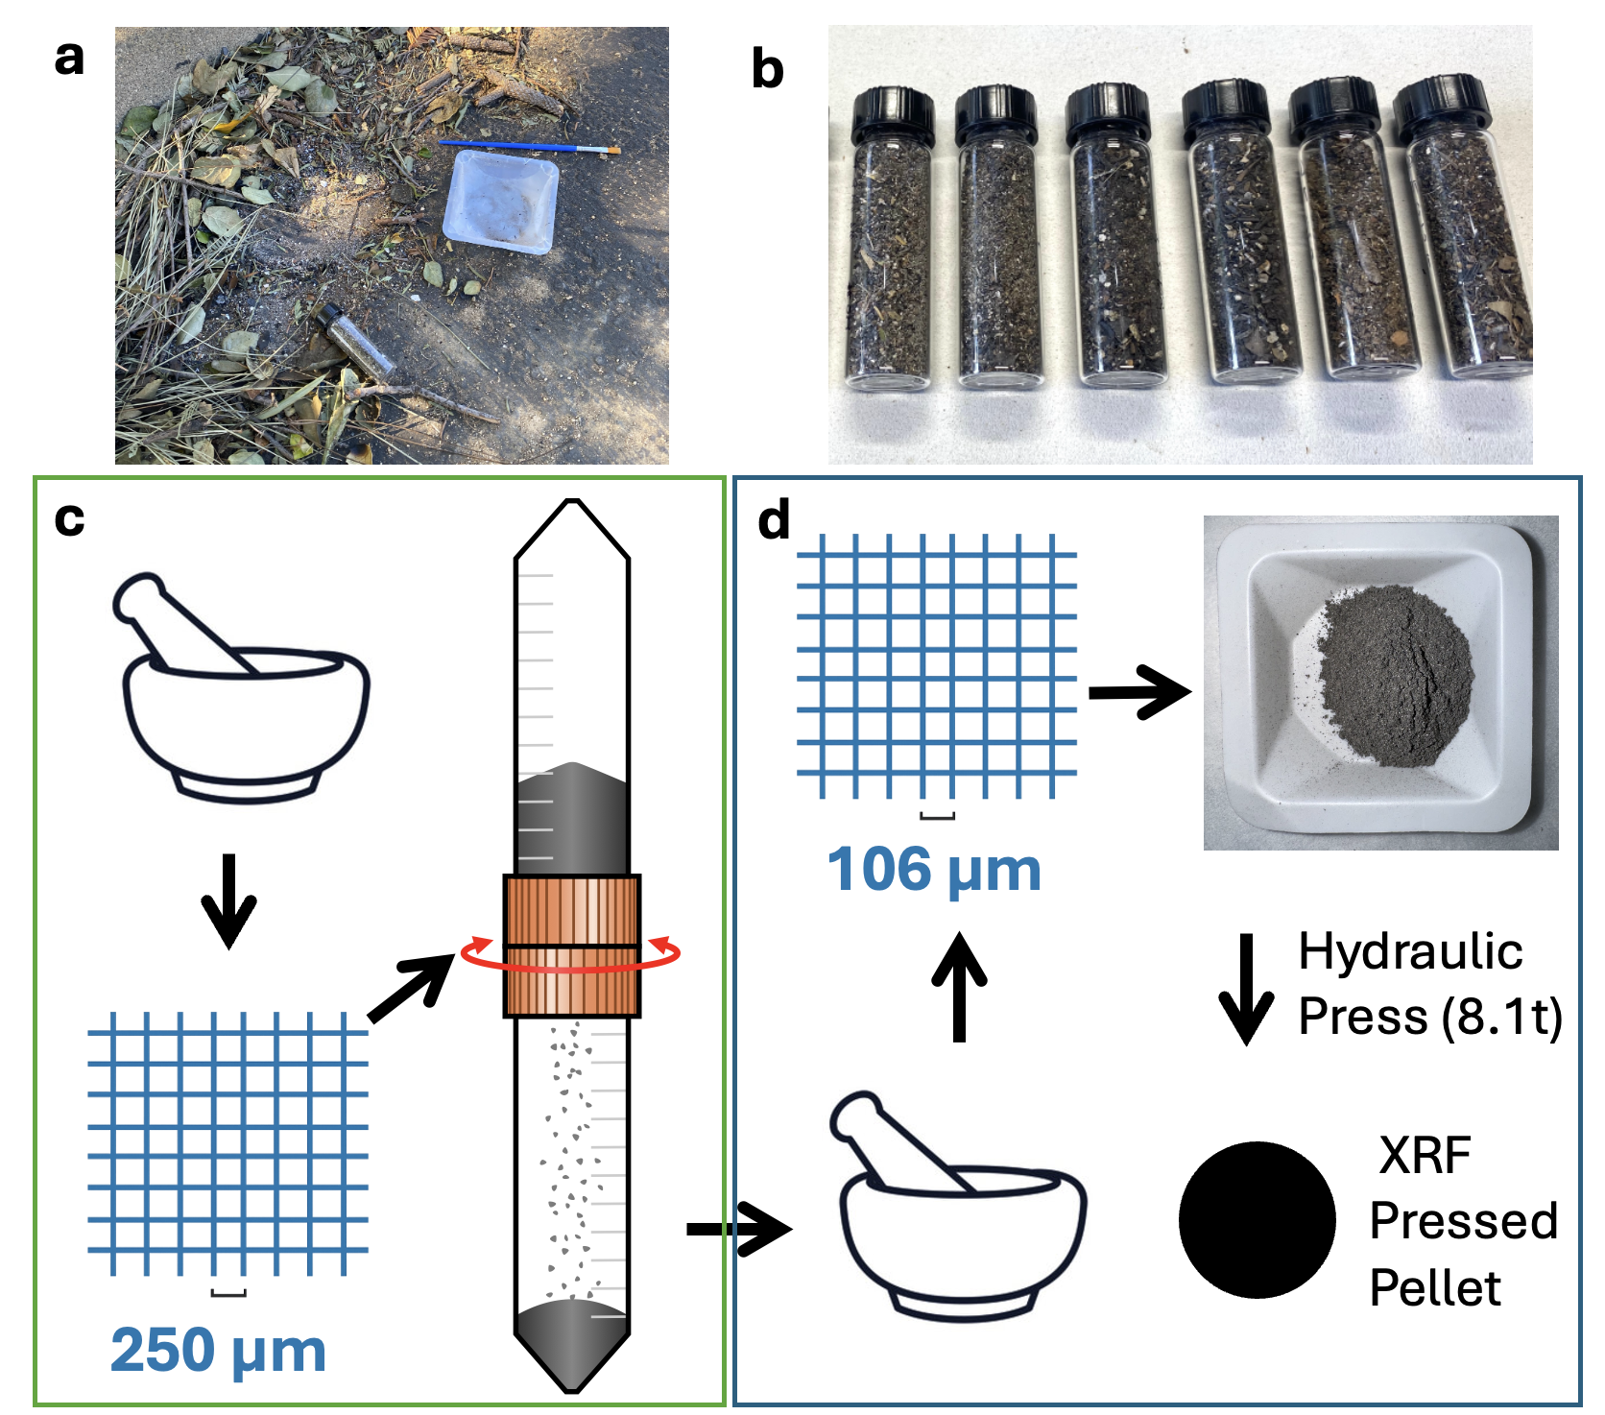
Figure 2. Ash samples were collected from outdoor surfaces including impervious wind-traps like residential sidewalks, road curbs, etc.
We selected 39 ash samples for their spatial and temporal (pre-rainfall) representation to proceed with elemental analysis via Inductively Coupled Plasma Mass Spectrometry (ICPMS). A subsample of each was aliquoted for parallel Pb content analysis with a benchtop energy-dispersive X-ray Fluorescence (XRF) spectrometer (INAM Expert 3L, RPE Institute of Analytical Control Methods, LLC). The instrument is equipped with a high-resolution Silica Drift Detector and an X-ray source tube (Rh anode, 50kv max voltage, 1000 uA max current), enabling detection of elements from Sodium (Na, Z=11) to Uranium (U, Z=92). To minimize grain-size effects, each ash subsample was homogenized by grinding and sieving to a fine powder (<106 µm) and then weighed to mix 330 mg of sample powder with 70 mg of cellulose binder before being pressed into a 13-mm diameter pellet under 8.1 tons of pressure for 5-10 seconds with a hydraulic press. XRF spectra from each sample pellet were acquired over 60 seconds of exposure with automatic peak deconvolution and matrix correction via the instrument’s fundamental parameters software package that reported semi-quantitative results in mass fraction percentage (mf. %). Instead of relying on this calculation, we report XRF data in units of counts per second (cts/s) as the cumulative x-ray photons detected from the Pb Lα₁, Lβ₁, and Lβ₂ energy lines because of their minimal interference with other elements.
Results
ICP-MS analysis quantified over 50 elements in the 39 candidate ash samples including major elements from biomass combustion residue and trace metals of environmental concern. Calcium was the most abundant element (mean 52,728 ppm), followed by iron (36,577 ppm) and aluminum (36,613 ppm) at comparable concentrations (Table 1). Potassium, magnesium, and sodium ranged from 13,000–19,000 ppm. Titanium (6,138 ppm) and manganese (962 ppm) were present at lower concentrations. Calcium and magnesium exhibited the highest variability among major elements (CV = 116% and 125%, respectively), while potassium was most uniformly distributed (CV = 31%).
ICP-MS analysis measured hazardous metals like lead, zinc, and copper (Table 2). Zinc concentrations ranged from 100 to 23,829 ppm (mean 1,310 ppm), while lead ranged from 14 to 18,528 ppm (mean 638 ppm). Copper concentrations spanned 14–3,650 ppm (mean 207 ppm). Vanadium, chromium, nickel, and cobalt were present at average concentrations of 22–85 ppm. Antimony averaged 9.1 ppm while arsenic and cadmium remained below 7 ppm and 1 ppm, respectively, across all samples. Vanadium and arsenic were comparatively uniform (CV = 31% and 33%). Whereas lead, zinc, and copper exhibited pronounced spatial heterogeneity (CV = 464%, 292%, and 284%), with maximum concentrations exceeding means by 1–2 orders of magnitude.
Table 1. Elemental concentrations (ppm) in Eaton Fire ashes (n=39)
1B. Metal contaminants (rank order of variation %)
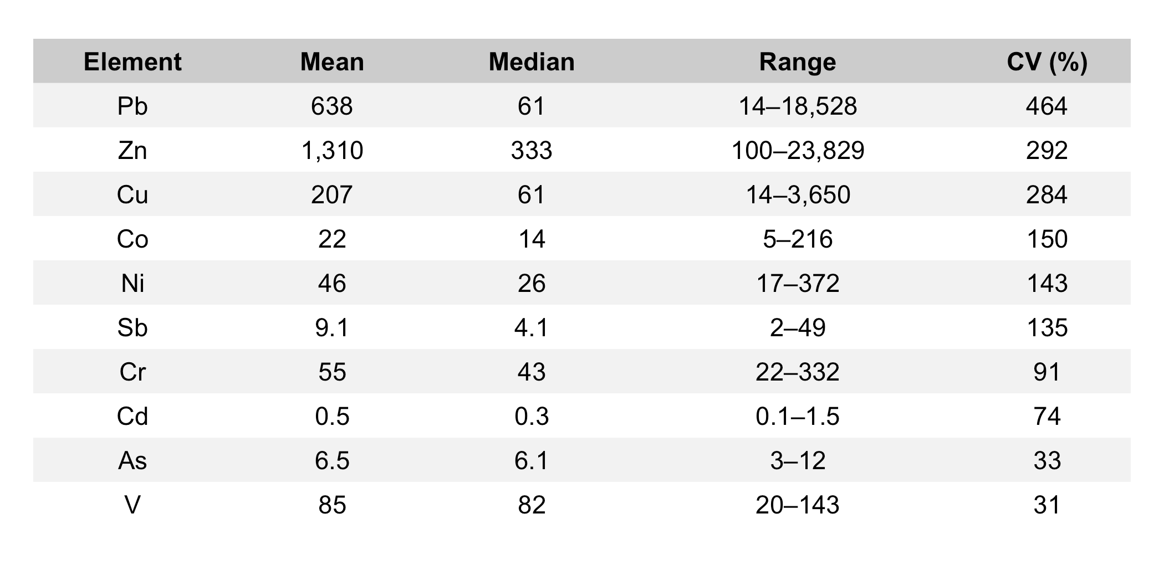

Table 1. Elemental concentrations (ppm) in Eaton Fire ashes (n=39)
1A. Major elements (rank order of mean concentration)
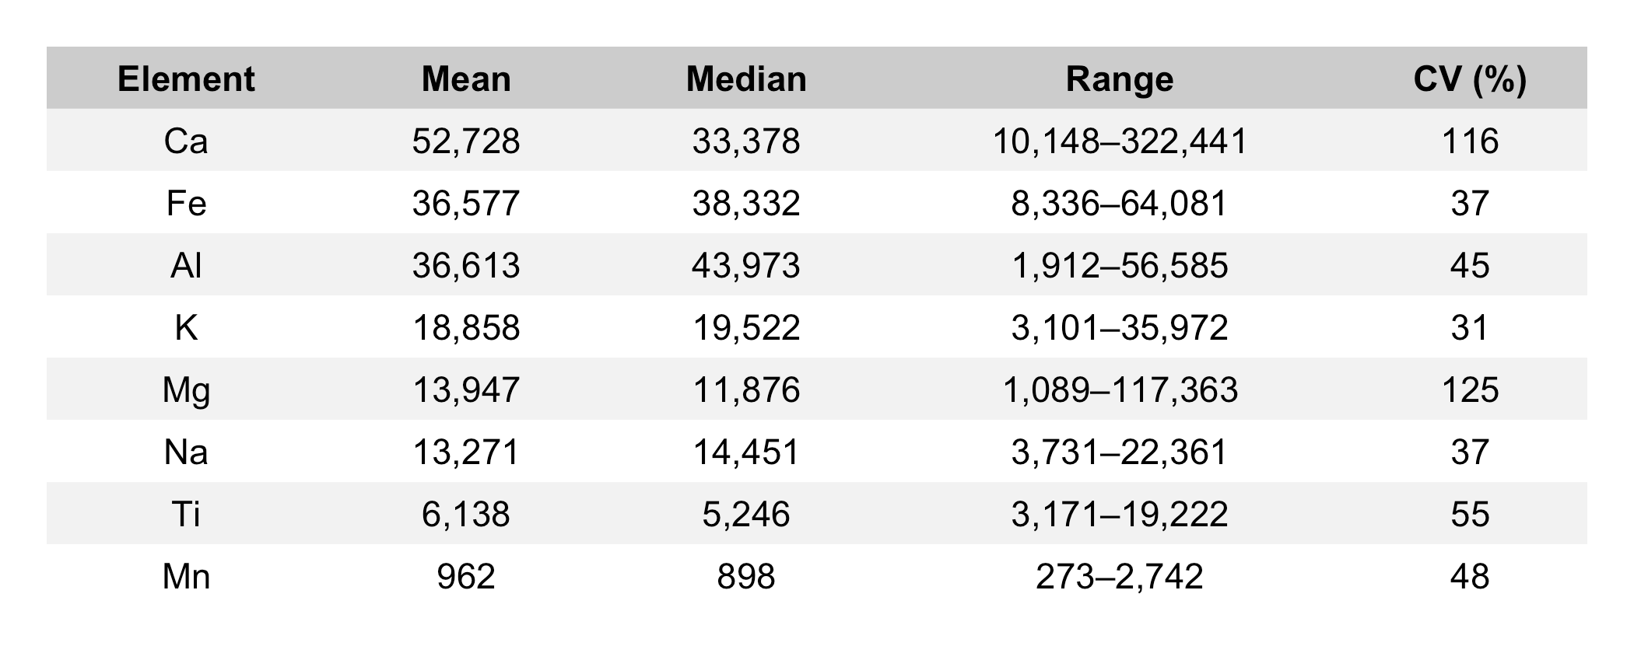
1B. Metal contaminants (rank order of variation %)


Linear regression models were developed to calibrate XRF measurements against ICP-MS Pb concentrations using 35 candidate paired ash subsamples (Table 3). Two approaches were compared: (1) manufacturer-reported mf. % values derived from the instrument's fundamental parameters (FP) algorithm, and (2) cumulative raw X-ray intensity (counts) from Pb L-emission lines (Lα₁ + Lβ₁ + Lβ₂). The FP-derived mf. % model yielded R² = 0.980 with RMSE = 431 ppm (Pb_ICP-MS = 5,732 × Pb_XRF_mf% − 185; p < 0.001). The cumulative L-line intensity model produced a stronger fit (R² = 0.994, RMSE = 230 ppm; Pb_ICP-MS = 0.817 × Pb_L-counts − 133; p < 0.001). Model comparison indicated substantial support for raw counts over FP-processed values (ΔAIC = 44).
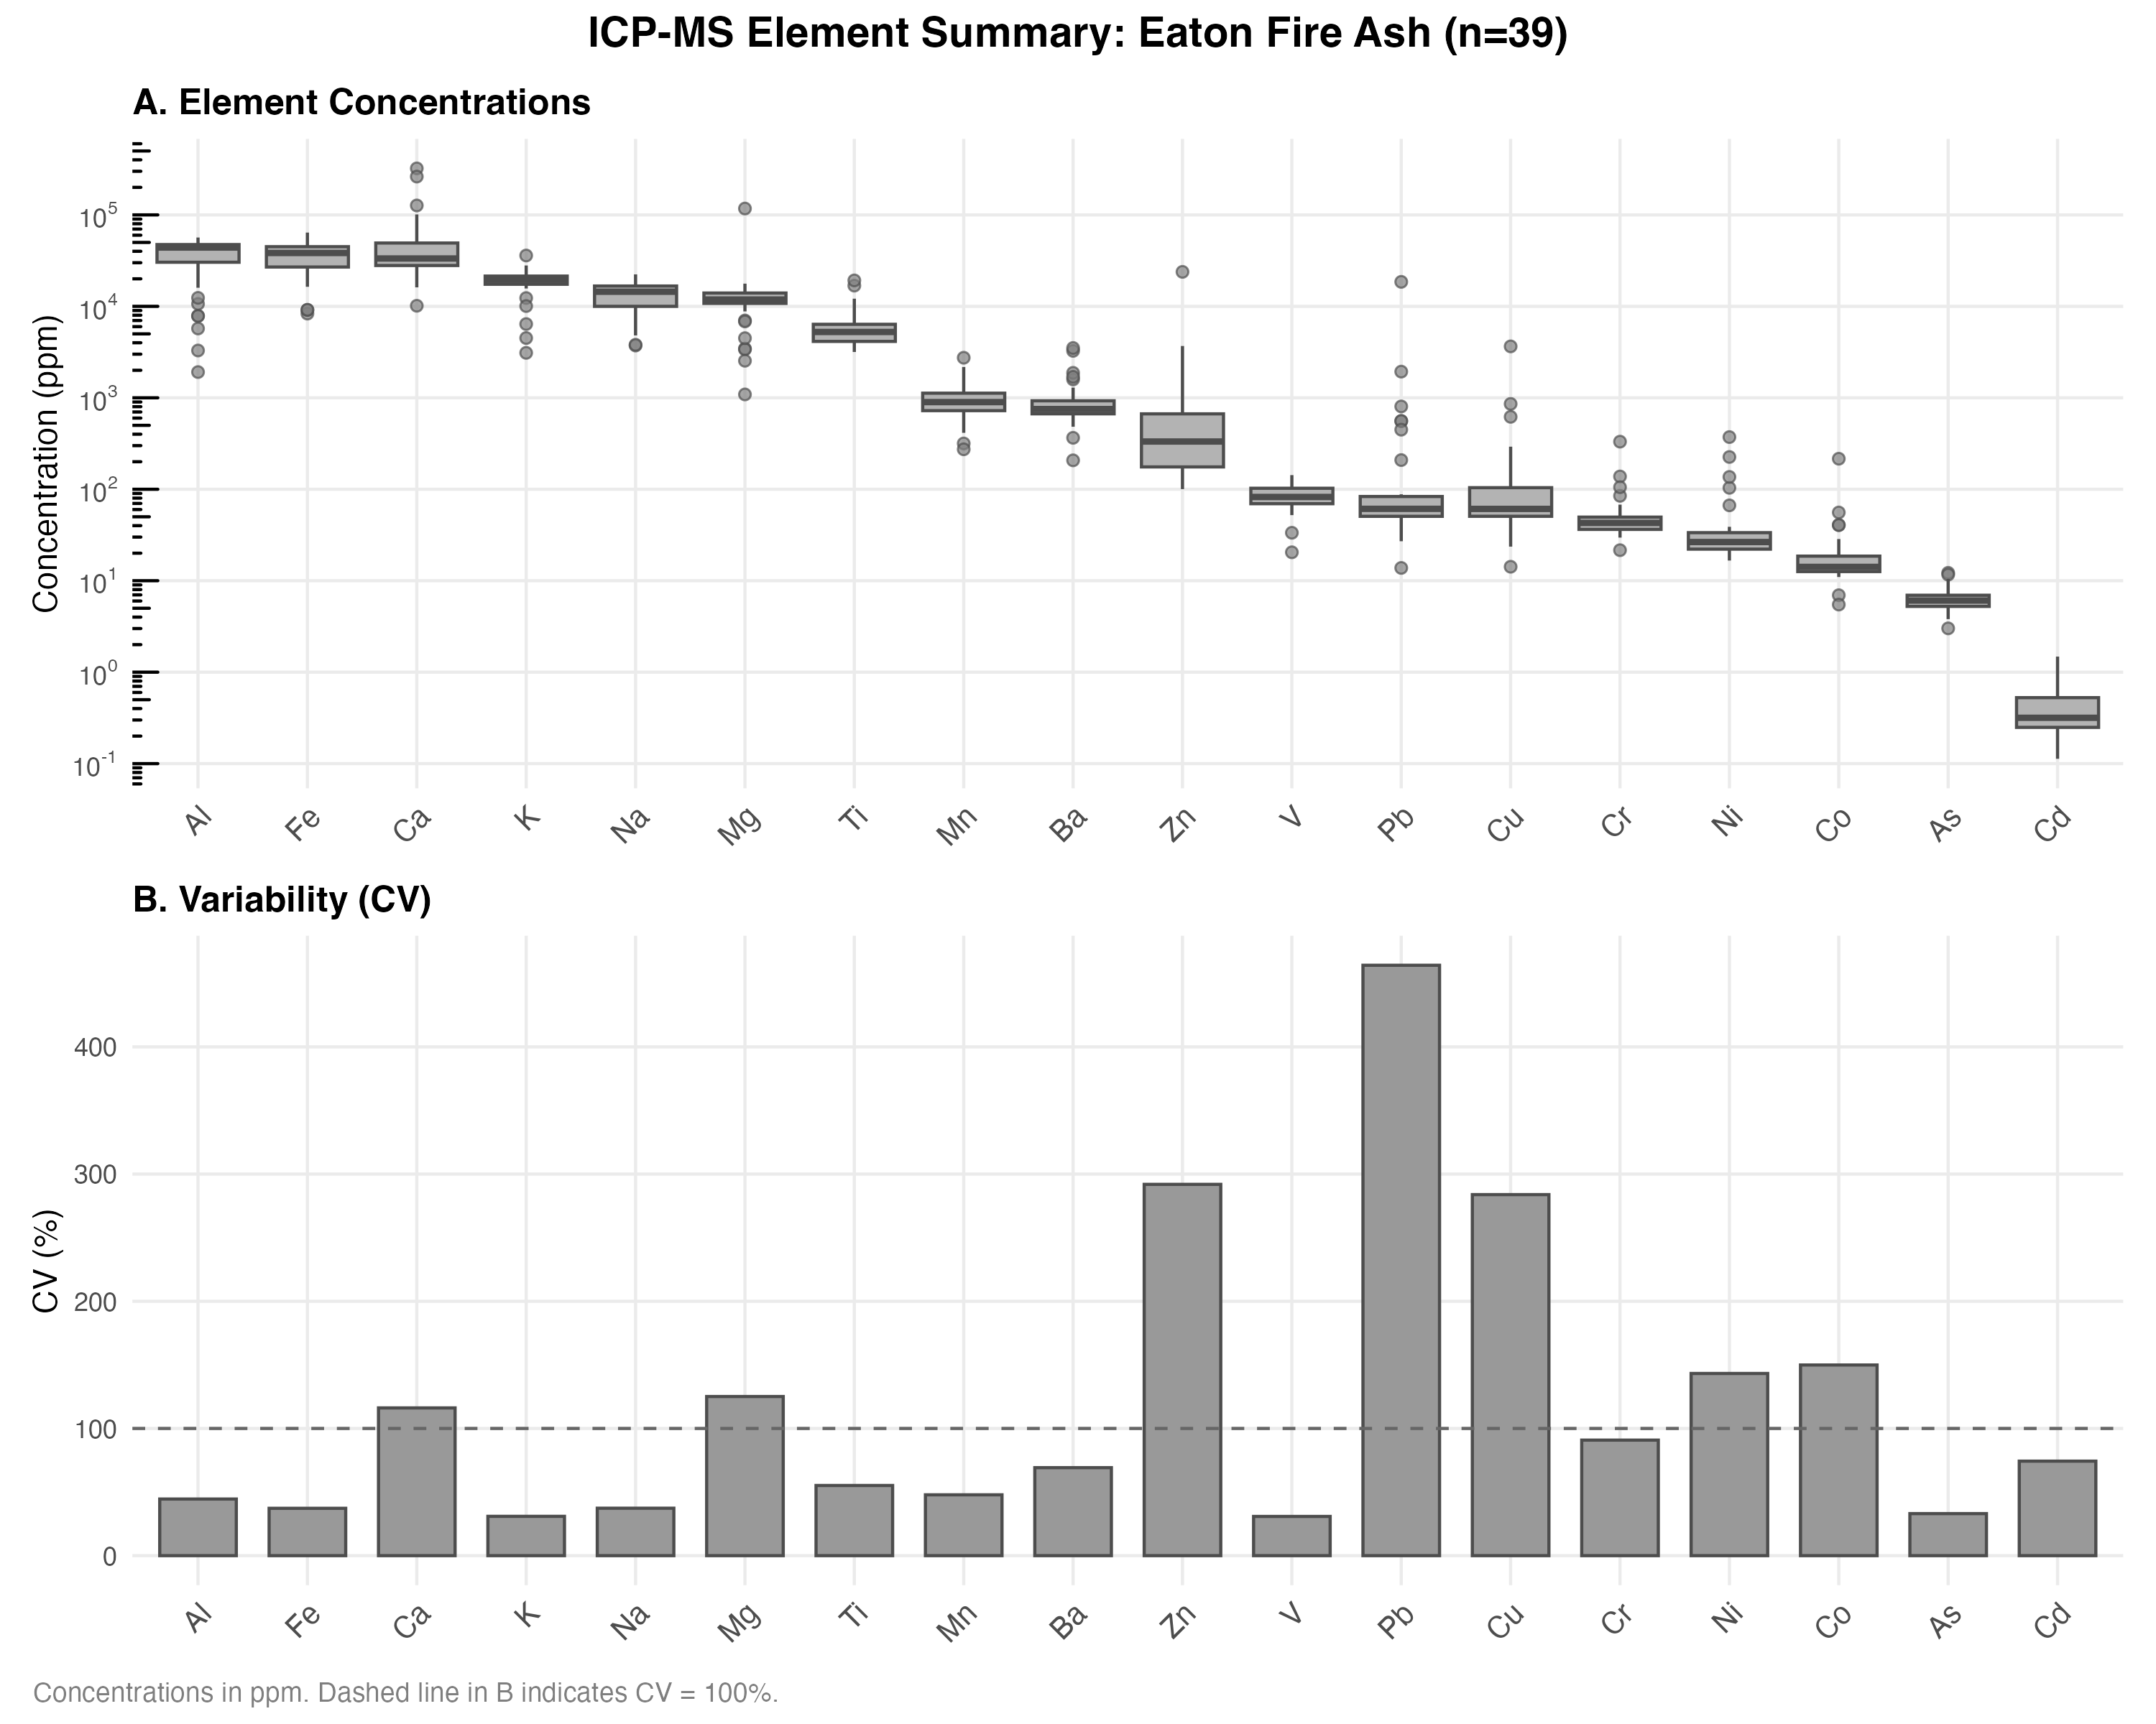
Figure 2. Rank-order box plot of the (A) elements with the highest average concentration across all ashes and (B) coefficient of variation among samples. Notably, geogenic elements have high concentrations and low variability while pyrogenic elements have mid- to high concentrations and extremely high variability (e.g. Zn, Pb, etc.).
Table 3. Linear regression models for XRF calibration of Pb against ICP-MS (n=35)
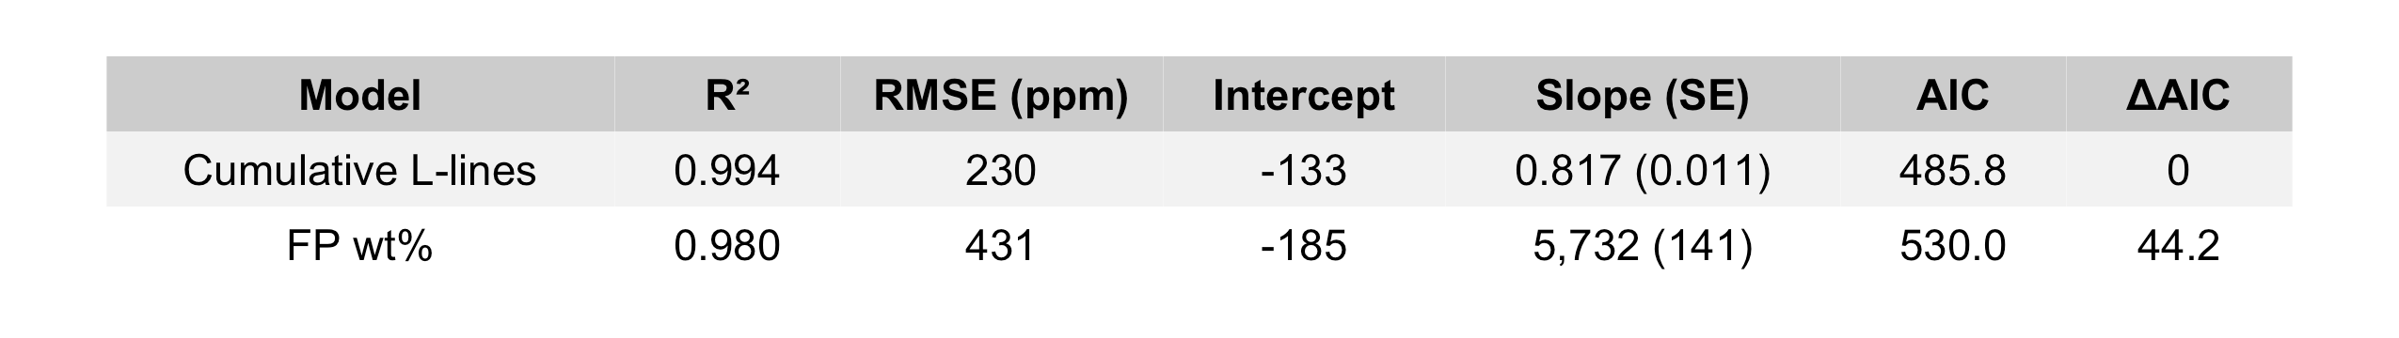
Calibrated XRF models were evaluated for their ability to classify samples as exceeding soil regulatory screening thresholds of 80, 200, 400, and 1000 ppm Pb (Table 4). Based on ICP-MS, 11 (31%), 7 (20%), 6 (17%), and 2 (6%) of 35 samples exceeded these thresholds, respectively. Classification performance improved with increasing threshold concentration. At 400 ppm, the cumulative L-lines model achieved 100% sensitivity and 100% specificity with no misclassifications. The Lα₁ and FP models each produced one false negative (sensitivity = 83%). At 1000 ppm, all calibrated models achieved 100% sensitivity; each produced one false positive (specificity = 97%). At lower thresholds, sensitivity declined while specificity remained high. At 200 ppm, the Lβ model achieved 86% sensitivity and 100% specificity (1 false negative). At 80 ppm, sensitivity ranged from 55–64% across models with 4–5 false negatives, while specificity remained above 83%. Alternative calibrations excluding high-concentration samples (>400 or >1000 ppm) were evaluated but did not improve overall classification performance. Restricted-range models increased sensitivity at 80 ppm but decreased sensitivity at 400 ppm due to underestimation from shallower regression slopes.
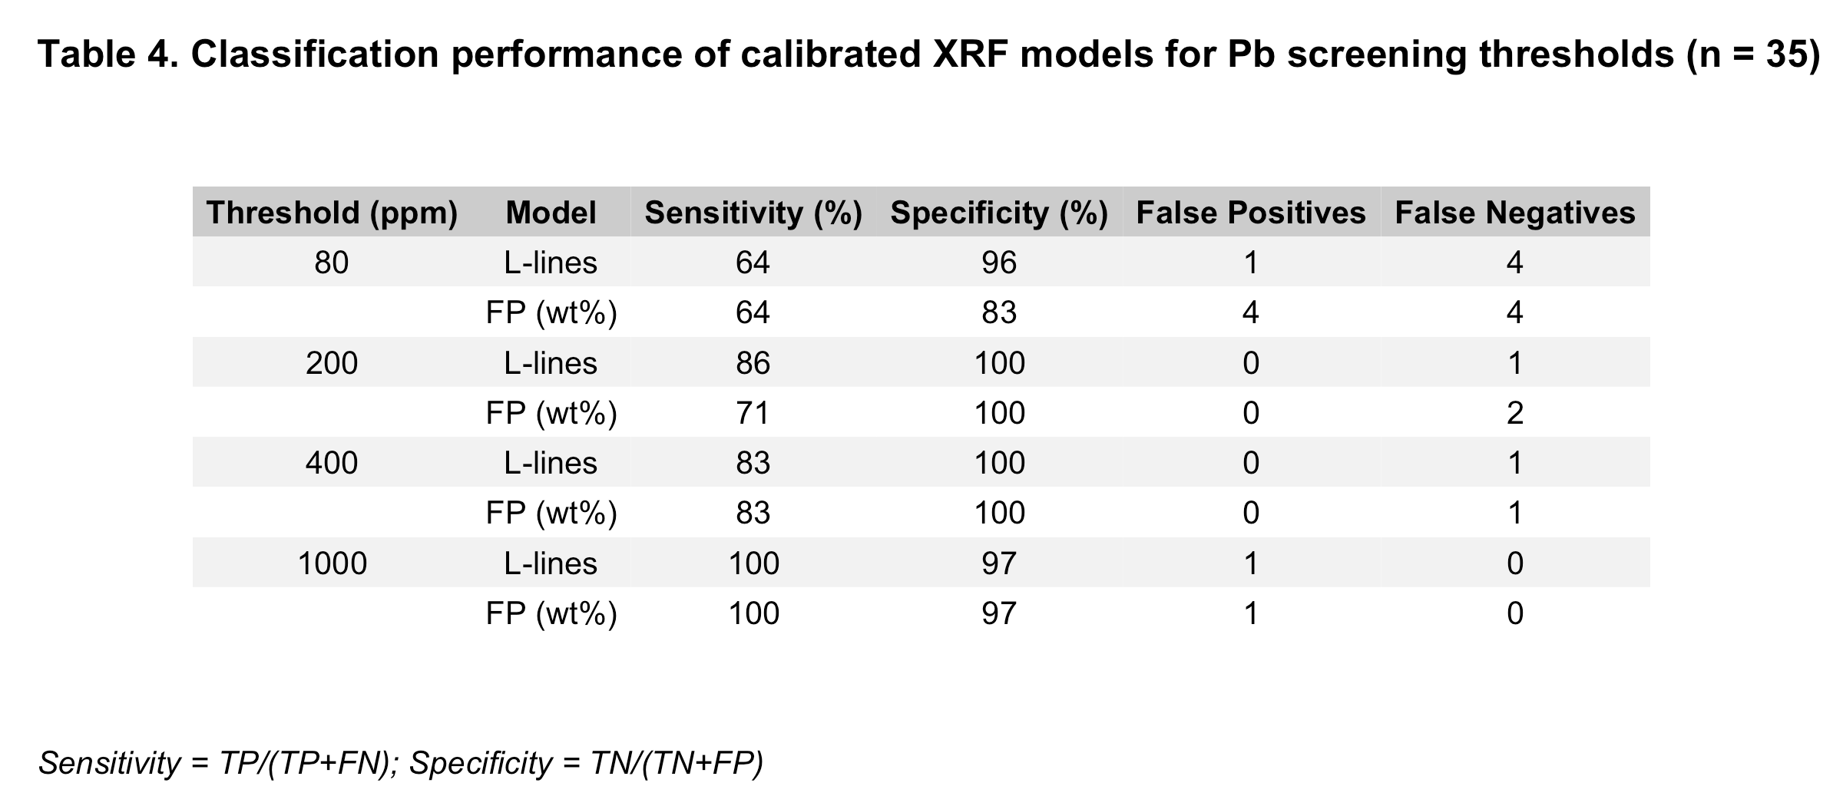

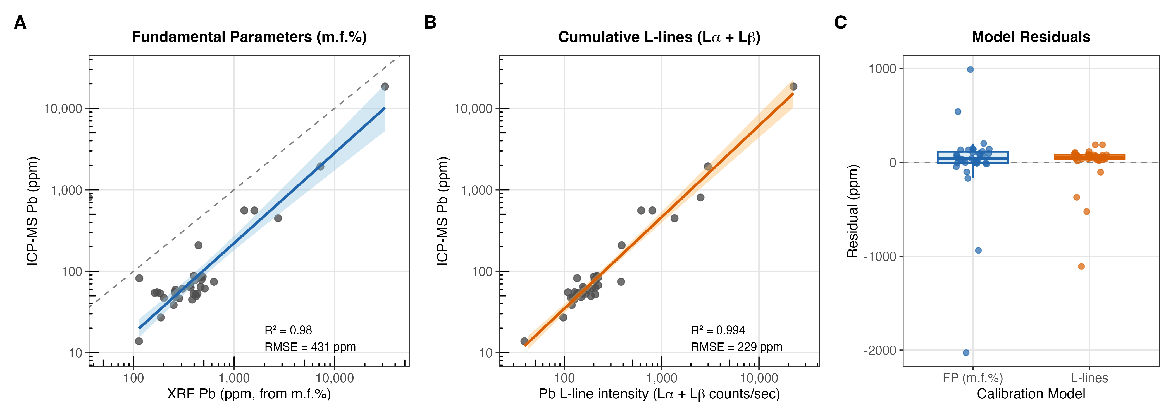Figure 3. Linear regression model used in calibrating XRF data from (A) Fundamental Parameter’s mf. % and (B) cumulative counts/sec from Pb L-lines compared with a (C) residual analysis.
Discussion
The metals of concern, namely Pb, Zn, Cu, and Co, were more concentrated in the ashes collected from within the urban burn perimeter compared to ashes collected beyond the burned perimeter, reflecting the spatial effect of pre-fire urban land cover on metal composition in ash. Metal elements with the highest concentrations across all ashes (Al, Fe, Ti, etc.) reflect the geological regime of native rocks and minerals from the surrounding landscape. These geogenic elements have low variability and are present in relatively the same amount across all the ashes. Pyrogenic elements are enriched in post-fire areas where a mosaic of materials from the built environment are combusted can enhance metal contamination and variation in ash composition. Among the elements detected, the highest variation in concentration across all ash samples included Pb, Zn, Cu, and Co. This is consistent with the extreme heterogeneity of post-fire metal contamination of residential soils studied in previous WUI fires where a mosaic of point-source metal emissions in addition to vegetation is combusted ^{3,4,6,8}. Pre-fire WUI regions can be very dissimilar, and thus the wildfire events that occur in the WUI can be highly variable. The unique source of combusted material likely affects the composition and distribution of fire-related contaminants.
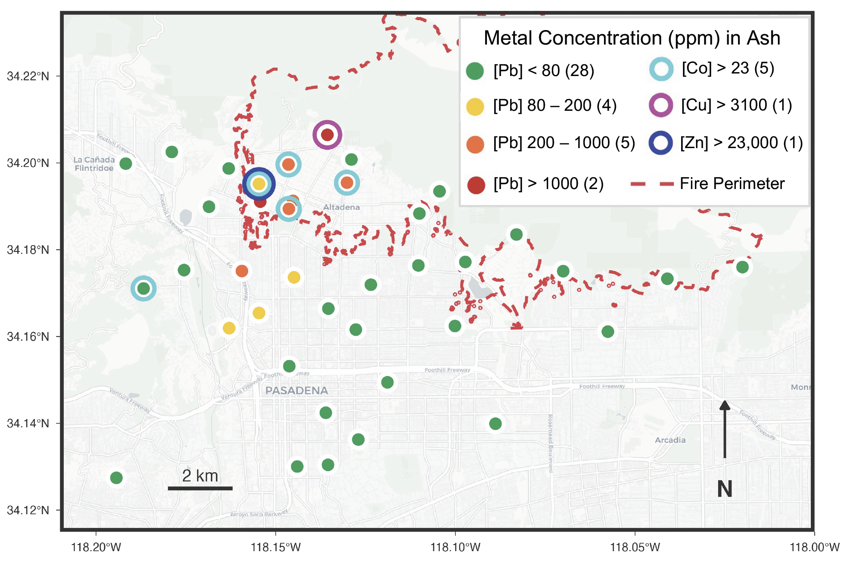
Figure 4. Map of the ash samples with color symbology reflecting screening thresholds for metal contaminants including Pb, Zn, Cu, and Co.
WUI fires are complex disasters that contaminate multiple environmental media including the air, land, and water with ashes. Presently, wildfire evacuation guidelines do not consider the additional pathways of wildfire ash exposure on risk assessment. Furthermore, there exists no uniform emergency response framework that addresses post-fire habitability and reoccupancy based on environmental exposure. Lead (Pb) is a toxic metal that can cause damage to almost all organs and organ systems with even very low levels of lead exposure ^{20–22}. The rapid detection of a spike in suspended Pb aerosols ¹⁹ preceded our parallel discovery of high concentrations of Pb in ashes on outdoor urban surfaces, including two samples from within the burned perimeter that exceed the State of California’s Total Toxicity Threshold Limit of 1000 ppm. Notably, ash samples down-wind from the urban fire perimeter also exceeded Pb concentration thresholds for Regional Screening Levels (RSLs) usually applied to soils contaminated by industrial metal processing plants. The South-west prevailing wind direction during the fire suggests the aeolian transport of WUI ash contaminated with metals from a dense pre-fire concentration of combustible urban materials including housing and buisness structures, electronic wiring and infrastructure, and other metals-rich manufactured goods and products like electric vehicles (EVs). The following conclusion is dedicated to the application of X-Ray Fluorescence (XRF) spectroscopy for the purpose of rapid WUI ash assessment in the field and delineation of toxic ash zones.
XRF spectroscopy quantifies elemental composition by measuring characteristic X-ray emissions induced by primary X-ray excitation of a sample. The technique is widely used for environmental screening due to its non-destructive nature, rapid analysis time, and portability. Commercially available instruments range from handheld field-portable devices to benchtop laboratory systems, with varying excitation sources (tube vs. radioisotope), detector technologies (Si-PIN, SDD, proportional counter), and quantification algorithms. These differences influence detection limits, spectral resolution, and matrix correction capabilities. XRF analysis of heterogeneous environmental matrices such as wildfire ash is not straightforward. Physical matrix effects arise from variations in sample density, particle size, surface roughness, and moisture content, which influence X-ray penetration depth and fluorescence yield. Chemical matrix effects occur when major element composition affects X-ray absorption and secondary fluorescence, requiring empirical or fundamental parameters corrections that may not be optimized for all sample types ²³.
Empirical calibration using cumulative L-line intensities (Lα + Lβ) improved both quantitative accuracy and threshold classification performance. The L-line model achieved 100% sensitivity at the 1000 ppm threshold, 83% sensitivity at 400 ppm, and 86% sensitivity at 200 ppm, with 100% specificity at all three thresholds (i.e., no false positives). Classification performance declined at the 80 ppm threshold (64% sensitivity, 96% specificity), reflecting increased uncertainty at concentrations approaching the calibration intercept. These results indicate that field-portable XRF with site-specific calibration can reliably identify samples exceeding moderate-to-high regulatory thresholds (≥200 ppm) but may underestimate contamination at lower screening levels.
Based on these findings, we recommend the following practices for similar analyses of WUI ash: (1) develop site-specific calibration models with paired XRF and ICP-MS measurements spanning the expected concentration range; (2) report raw emission line intensities alongside any instrument-derived concentrations to enable cross-instrument recalibration; (3) consider screening thresholds (e.g., 200 ppm) for field sampling with portable XRF in a post-fire WUI; and (4) confirm exceedances and borderline samples with laboratory ICP-MS analysis.
References
1. Radeloff, V. C. et al. Rapid growth of the US wildland-urban interface raises wildfire risk. Proc. Natl. Acad. Sci. 115, 3314–3319 (2018).
2. Young, S., Balluz, L. & Malilay, J. Natural and technologic hazardous material releases during and after natural disasters: a review. Sci. Total Environ. 322, 3–20 (2004).
3. Jech, S. et al. Determination of Soil Contamination at the Wildland-Urban Interface after the 2021 Marshall Fire in Colorado, USA. Environ. Sci. Technol. 58, 4326–4333 (2024).
4. Villarruel, C. M., Figueroa, L. A. & Ranville, J. F. Quantification of Bioaccessible and Environmentally Relevant Trace Metals in Structure Ash from a Wildland–Urban Interface Fire. Environ. Sci. Technol. 58, 2502–2513 (2024).
5. Pereira, P. & Úbeda, X. Spatial distribution of heavy metals released from ashes after a wildfire. J. Environ. Eng. Landsc. Manag. 18, 13–22 (2010).
6. Fernandez-Marcos, M. L. Potentially Toxic Substances and Associated Risks in Soils Affected by Wildfires: A Review. Toxics 10, 31 (2022).
7. Terzano, R. et al. Fire effects on the distribution and bioavailability of potentially toxic elements (PTEs) in agricultural soils. Chemosphere 281, 130752 (2021).
8. Abraham, J., Dowling, K. & Florentine, S. The Unquantified Risk of Post-Fire Metal Concentration in Soil: a Review. Water. Air. Soil Pollut. 228, 175 (2017).
9. Alshehri, T. et al. Wildland-urban interface fire ashes as a major source of incidental nanomaterials. J. Hazard. Mater. 443, 130311 (2023).
10. Alexakis, D. E. Suburban areas in flames: Dispersion of potentially toxic elements from burned vegetation and buildings. Estimation of the associated ecological and human health risk. Environ. Res. 183, 109153 (2020).
11. Committee on the Chemistry of Urban Wildfires, Board on Chemical Sciences and Technology, Division on Earth and Life Studies, & National Academies of Sciences, Engineering, and Medicine. The Chemistry of Fires at the Wildland-Urban Interface. 26460 (National Academies Press, Washington, D.C., 2022). doi:10.17226/26460.
12. Senior, C. L., Bool, L. E., Srinivasachar, S., Pease, B. R. & Porle, K. Pilot scale study of trace element vaporization and condensation during combustion of a pulverized sub-bituminous coal. Fuel Process. Technol. 63, 149–165 (2000).
13. Sánchez-García, C. et al. Chemical characteristics of wildfire ash across the globe and their environmental and socio-economic implications. Environ. Int. 178, 108065 (2023).
14. Etiégni, L. & Campbell, A. G. Physical and chemical characteristics of wood ash. Bioresour. Technol. 37, 173–178 (1991).
15. Campos, I., Abrantes, N., Keizer, J. J., Vale, C. & Pereira, P. Major and trace elements in soils and ashes of eucalypt and pine forest plantations in Portugal following a wildfire. Sci. Total Environ. 572, 1363–1376 (2016).
16. Schissel, C. et al. Fine Spatial and Temporal Scale Fuel and Emissions Inventories for the Eaton and Palisades Wildland Urban Interface (WUI) Fires. ACS EST Air https://doi.org/10.1021/acsestair.5c00287 (2025) doi:10.1021/acsestair.5c00287.
17. CAL FIRE. Eaton Fire Incident Report. (2025).
18. National Weather Service. Wind Event Advisory. (2025).
19. Baliaka, H. D. Notes from the Field: Elevated Atmospheric Lead Levels During the Los Angeles Urban Fires — California, January 2025. MMWR Morb. Mortal. Wkly. Rep. 74, (2025).
20. Tong, S., von Schirnding, Y. E. & Prapamontol, T. Environmental lead exposure: a public health problem of global dimensions. Bull. World Health Organ. 78, 1068–1077 (2000).
21. Jusko, T. A. et al. Blood Lead Concentrations < 10 μg/dL and Child Intelligence at 6 Years of Age. Environ. Health Perspect. 116, 243–248 (2008).
22. Levin, R. et al. Lead exposures in U.S. Children, 2008: implications for prevention. Environ. Health Perspect. 116, 1285–1293 (2008).
23. Ravansari, R., Wilson, S. C. & Tighe, M. Portable X-ray fluorescence for environmental assessment of soils: Not just a point and shoot method. Environ. Int. 134, 105250 (2020).

